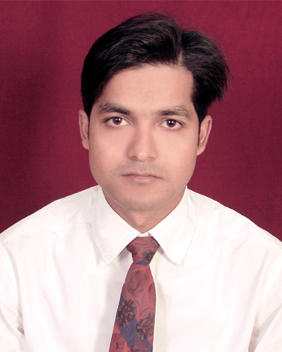
MD. CHAND ALI

Present Address
RZ-2802/31, 3rd floor,
Tuglakabad Extension,
New Delhi-110019
E-mail: chandali86@gmail.com
Contact Number: +91- 9891252957
+91-7827815611

Career Objective
Looking for a suitable position in an organization where I can utilize my knowledge and expertise to contribute to the success of the organization and to grow as a successful person.

Educational Qualification

Examination | Board/University | Session
B.Pharm | Jamia Hamdard, New Delhi | 2008-2011
D.Pharm | Jamia Hamdard, New Delhi | 2005-2007
Intermediate | B.I.E.C. Patna | 2000-2002
Matriculation | B.S.E.B. Patna | 1998-2000

Computer Literacy
- Microsoft windows 98, 2000, XP & Vista.
- Microsoft office 2000, 2003, 2007.
- Internet browsing.

Extracurricular Activities
- Attended seminar on a satellite session of Third International Conference on Plants and Environmental Pollution.
- Actively participated in the Rx fest organized by the university in the faculty of Pharmacy.

Professional Training

  - Done three months training in Municipal Corporation of Delhi, Govt. of Delhi during D. Pharm.
  - Done Emergency Healthcare Training under Indian Red Cross Society, Patna, Bihar.
  - Done 15 days training in Abbys Pharmaceuticals Pvt. Ltd. New Delhi.
  - Registered pharmacist with DELHI PHARMACY COUNCIL INDIA.

Professional Experience
- Name of the Employer: Fortis health world , New Delhi, India
Designation: Pharmacist.
Duration: 19 September 2007 to 30th May 2008

- Name of the Employer:Mahajan Medicare New Delhi India
Designation: Pharmacist.(Part Time)
Duration: 1st june 2008 to till now

Strength
- Positive Attitude.
- Enthusiastic to achieve newer knowledge.
- Dedication towards work.
- Ready to face challenge.

Skills
- Working Knowledge of TP Pospro Software for Pharmacy Management.
- Good Knowledge of International Regulatory Guidelines.
- Good knowledge of Clinical Pharmacology.
- Good at documentation, report writing and correspondence.
- Pleasing Personality
- Ability to convince the customers.

Personal Details
Name : Md Chand Ali
Father's Name : Md Ishaque
Date of Birth : 5th February, 1986

Nationality : Indian
Gender : Male
Marital Status : Single
Languages Known : English, Hindi and Urdu
Hobbies : Internet surfing, Listening music

Declaration
I hereby declare that the above mentioned information is authentic and true to the best of my knowledge.
Place: New Delhi
Date:17-05-2011 MD. CHAND ALI

